SRM INSTITUTE OF SCIENCE AND TECHNOLOGY
TIRUCHIRAPPALLI

LABORATORY REPORT
Course:
Computer Networks Laboratory
Computer Networks Lab Test
B.Tech. in Computer Science and Engineering
(Specialization: Cyber Security)

Student Name:
Divijaa M
Register Number:
RA2411030050055
Department:
Cyber Security – A
Submitted To:
Dr. R. Mallikka

Lab 1: Getting Started with Packet Tracer, Peer-to-Peer Communication and Ethernet Cable Colour Codes

1. Aim
To become comfortable with the Cisco Packet Tracer environment, to set up a small network of two computers joined by a switch, to configure IP addresses and confirm peer-to-peer connectivity using ping, and to learn the wire colour schemes used in Ethernet cables.

2. Software Required
Cisco Packet Tracer running on a Windows PC.

3. Theory
Cisco Packet Tracer is a simulator used to design networks, configure devices and observe how they exchange data, all without physical equipment. The interface consists of a central workspace for building the topology, a device panel at the bottom for choosing end devices, switches, routers and cables, and a toolbar holding the common editing options.
In a peer-to-peer arrangement, computers communicate with one another directly and none of them is a dedicated server. Each machine needs its own IP address and a subnet mask, and machines that want to talk must belong to the same network. The ping utility transmits ICMP echo requests to a target and waits for replies, which makes it a quick way to test whether two devices can reach each other.
A straight-through cable is wired to the T568B standard at both ends and joins dissimilar devices, such as a PC and a switch. A crossover cable uses T568A on one end and T568B on the other, which swaps the transmit and receive pairs; it is meant for joining similar devices, such as two PCs.

4. Procedure
- Start Packet Tracer and look over the workspace, device panel and toolbar.
- Build the network: place two PCs (PC-PT) and one switch (Switch-PT) on the workspace, then link each PC to the switch with a straight-through Ethernet cable.
- Configure addressing: open PC0, go to Desktop > IP Configuration and enter 192.168.10.1 with mask 255.255.255.0. Repeat on PC1 using 192.168.10.2 and the same mask.
- Test connectivity: open the Command Prompt on PC0 and run ping 192.168.10.2, then check the replies.
- Study the cables: compare straight-through and crossover cables and note the colour order of each wire.

5. Implementation and Output

5.1 Building the Network
Two PCs (PC0 and PC1) and a switch were placed in the workspace. Each PC was attached to the switch with a straight-through cable, connecting the PC's FastEthernet port to a free switch port. After a few seconds the link indicators changed to green, showing that both links were active.
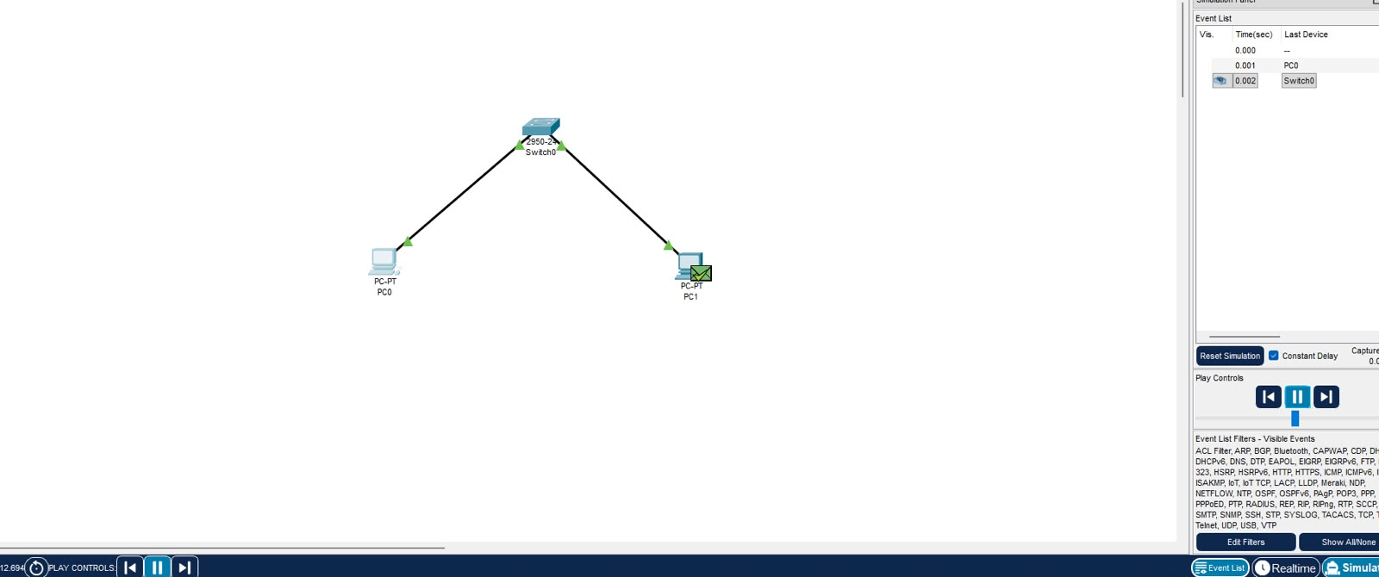
Fig. 1: Two PCs connected through a switch

5.2 Assigning IP Addresses
On PC0, the Static option under Desktop > IP Configuration was chosen and the address 192.168.10.1 with subnet mask 255.255.255.0 was entered. The same procedure was followed on PC1 with the address 192.168.10.2.
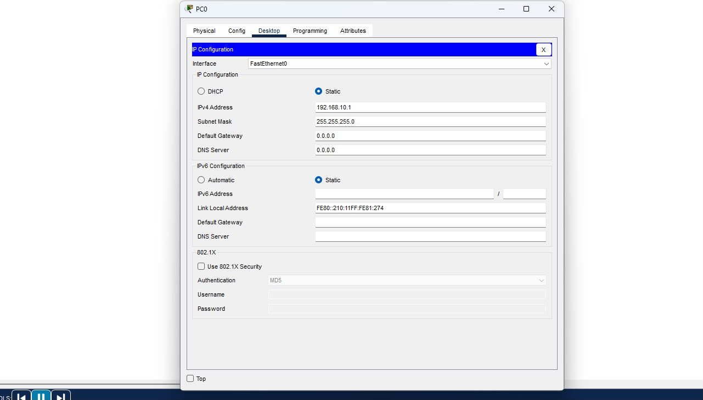
Fig. 2: IP configuration window of PC0

5.3 Checking Peer-to-Peer Communication
The command ping 192.168.10.2 was run from the Command Prompt of PC0. Four packets were sent and four replies came back with 0% loss, confirming that PC0 and PC1 can exchange data through the switch.
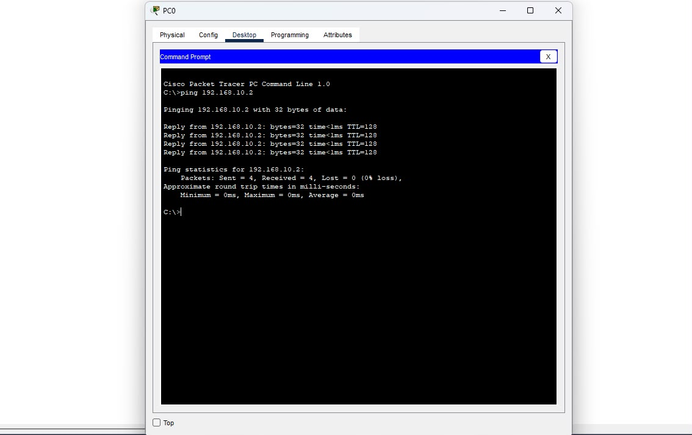
Fig. 3: Ping from PC0 to PC1

6. Ethernet Cables and Colour Codes
An Ethernet cable holds four twisted pairs (eight wires) that are arranged in a fixed order inside the RJ-45 plug. Two standard arrangements exist: T568A and T568B.

6.1 Straight-through Cable
Both plugs follow T568B (normally), so each pin on one end maps to the same pin on the other end. This cable links unlike devices, for instance PC to switch, PC to hub or router to switch.
Pin | End 1 (T568B) | End 2 (T568B)
1 | White/Orange | White/Orange
2 | Orange | Orange
3 | White/Green | White/Green
4 | Blue | Blue
5 | White/Blue | White/Blue
6 | Green | Green
7 | White/Brown | White/Brown
8 | Brown | Brown

6.2 Crossover Cable
One end is wired T568B and the other T568A. This exchanges the transmit pair (pins 1, 2) with the receive pair (pins 3, 6) so that two similar devices, such as PC to PC or switch to switch, can be linked directly.
Pin | End 1 (T568B) | End 2 (T568A)
1 | White/Orange | White/Green
2 | Orange | Green
3 | White/Green | White/Orange
4 | Blue | Blue
5 | White/Blue | White/Blue
6 | Green | Orange
7 | White/Brown | White/Brown
8 | Brown | Brown

6.3 Comparison
Feature | Straight-through | Crossover
Wiring | T568B on both ends | T568B on one end, T568A on the other
Used for | Different devices | Similar devices
Example | PC to switch | PC to PC

7. Result
The Packet Tracer interface was explored, and a network of two PCs and a switch was built using straight-through cables. With the addresses 192.168.10.1 and 192.168.10.2 configured, ping succeeded between the two PCs. The colour codes of straight-through and crossover cables were also studied.

8. Conclusion
This lab taught me how to work with the basic features of Packet Tracer, connect devices, assign IP addresses and test reachability with ping. It also clarified why straight-through cables suit dissimilar devices while crossover cables suit similar ones, and how the T568A and T568B orders differ.

Lab 2: Implementation of Network Topologies

1. Aim
To build bus, star, ring and mesh topologies in Cisco Packet Tracer using three computers in each, configure IP addresses, and verify that all computers can reach each other using ping.

2. Software Required
Cisco Packet Tracer running on a Windows PC.

3. Theory
A network topology describes how devices in a network are laid out and linked, either physically or logically. The chosen topology influences cabling cost, performance, ease of troubleshooting and how well the network tolerates a failed link or device.
In a bus topology, every device taps into a single shared backbone cable. It uses little cable, but a break in the backbone disables the whole network. In a star topology, each device connects to a central switch, so a faulty cable affects only one device, although the switch itself becomes a single point of failure. In a ring topology, every device is linked to exactly two neighbours, forming a closed loop around which data travels. In a mesh topology, each device has a direct link to every other device; this is the most dependable layout but requires the most cables and ports.

4. Procedure
- Launch Cisco Packet Tracer.
- Bus topology: place three computers and join them to a single backbone cable (coaxial).
- Star topology: place three computers and a switch, and connect each computer to the switch with straight-through Ethernet cables.
- Ring topology: place three computers and connect them in a circle using crossover cables.
- Mesh topology: place three computers and connect every computer to each of the others using crossover cables.
- Testing: assign IP addresses in each topology and use ping to check connectivity among all the computers.

5. Implementation and Output

5.1 Bus Topology
Three computers were joined to one backbone line. IP addresses from a common network were assigned through the Config tab. Pinging the other PCs from the Command Prompt of one PC returned a reply for every request.
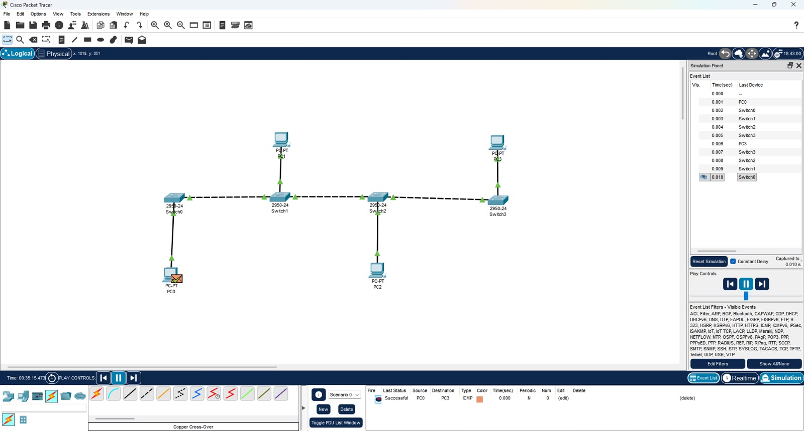
Fig. 1: Bus topology in Cisco Packet Tracer
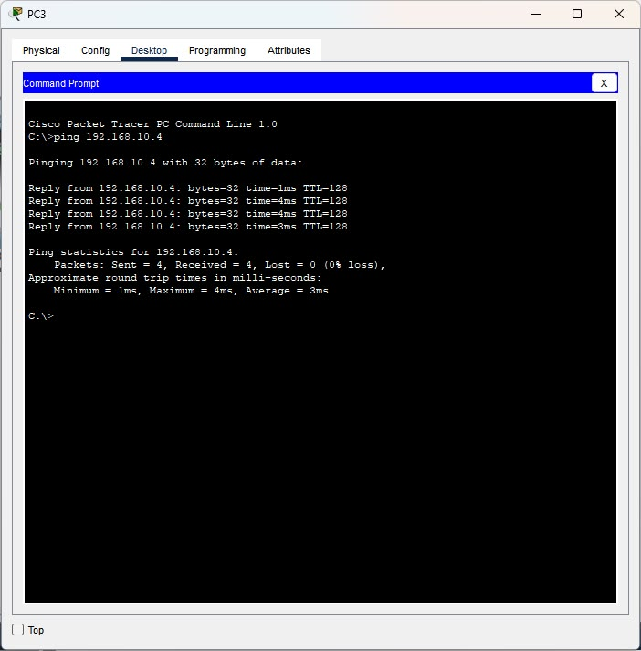
Fig. 2: Ping results among the PCs of the bus topology

5.2 Star Topology
A switch was placed in the middle and every computer was attached to it using a straight-through cable. After addressing, the PCs were pinged from one another via the switch and every ping succeeded.
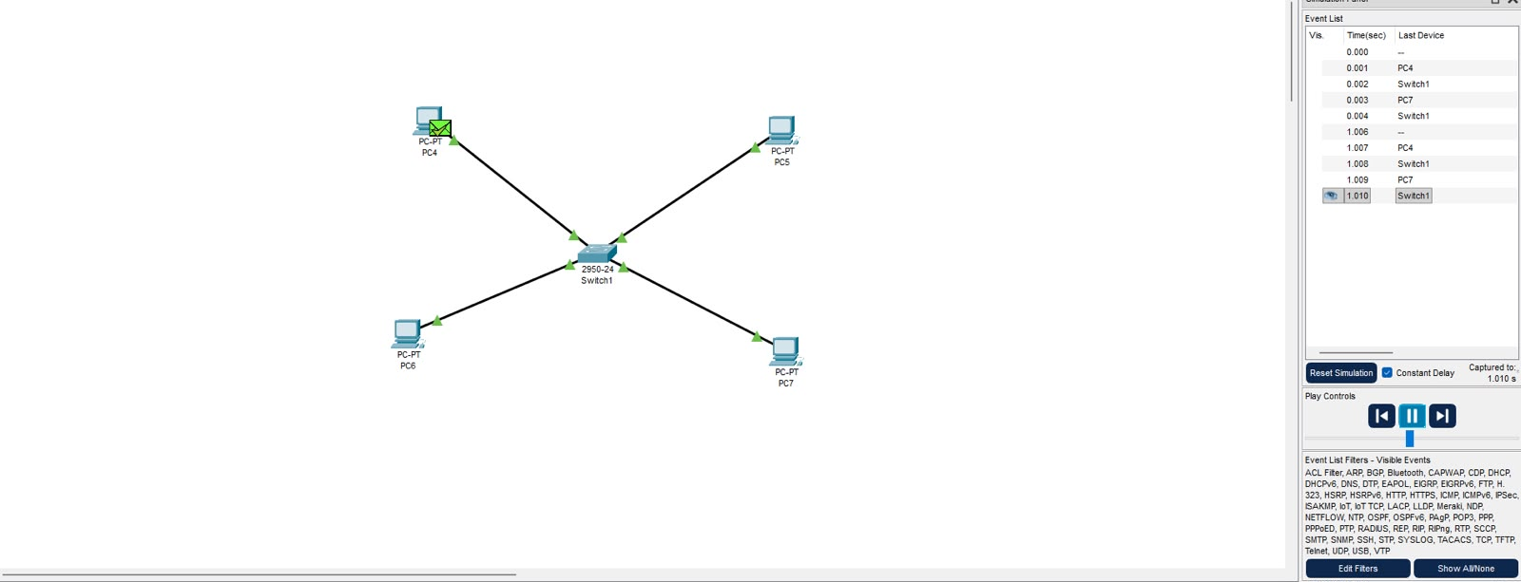
Fig. 3: Star topology in Cisco Packet Tracer
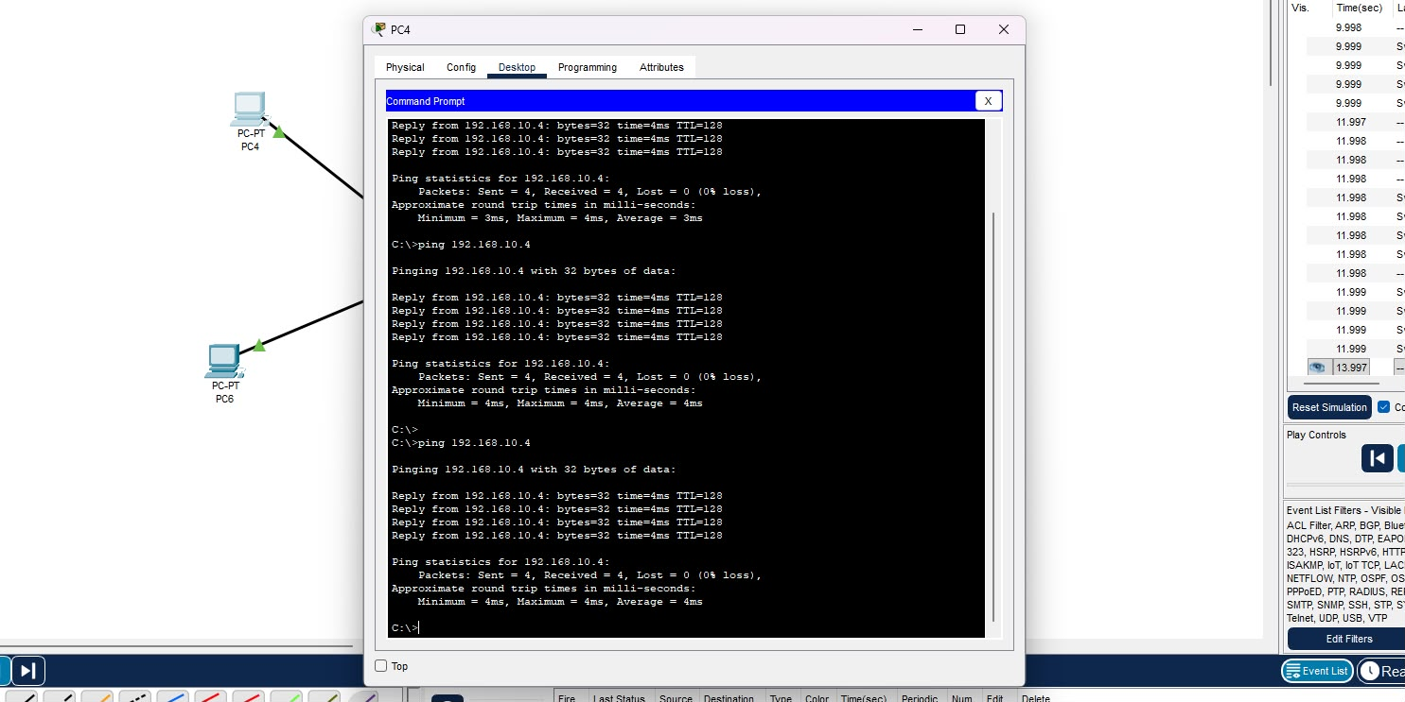
Fig. 4: Ping results among the PCs of the star topology

5.3 Ring Topology
The computers were linked one after the other in a loop using crossover cables, so each device has two neighbours. After configuring IP addresses, connectivity was verified with ping from the Command Prompt.
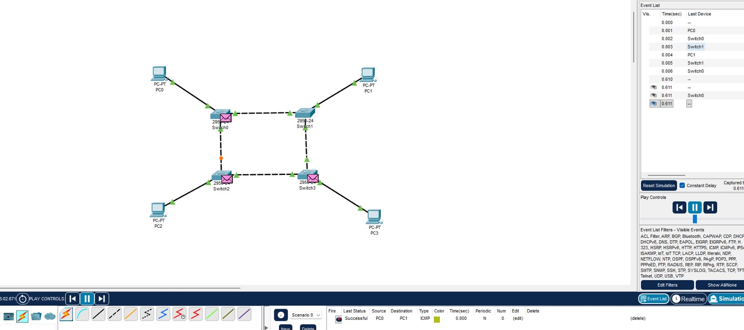
Fig. 5: Ring topology in Cisco Packet Tracer
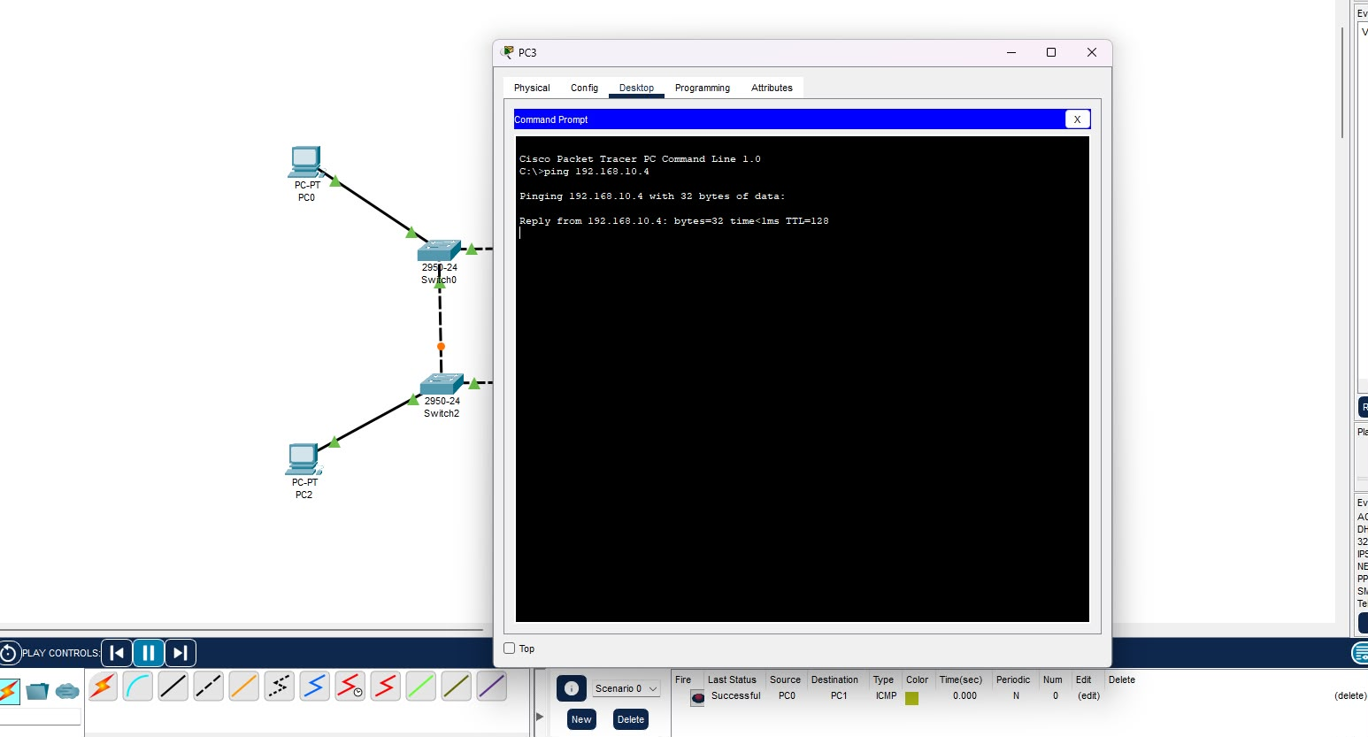
Fig. 6: Ping results among the PCs of the ring topology

5.4 Mesh Topology
In the mesh arrangement, every computer was wired to every other computer with crossover cables, giving each pair of devices a dedicated link. Once IP addresses were set, ping was used to test every path.
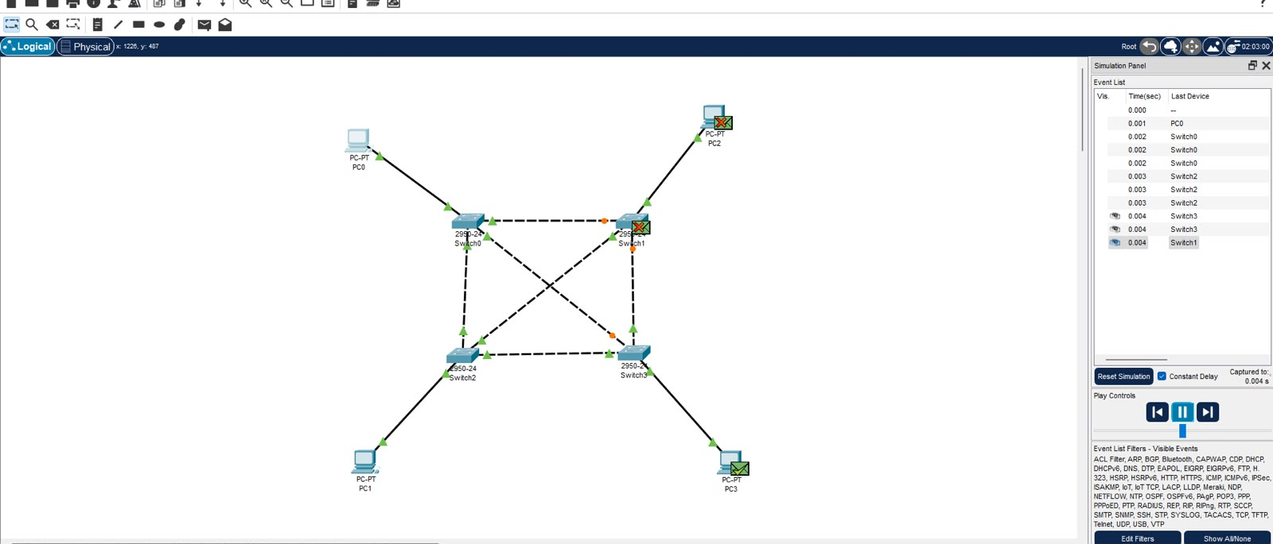
Fig. 7: Mesh topology in Cisco Packet Tracer
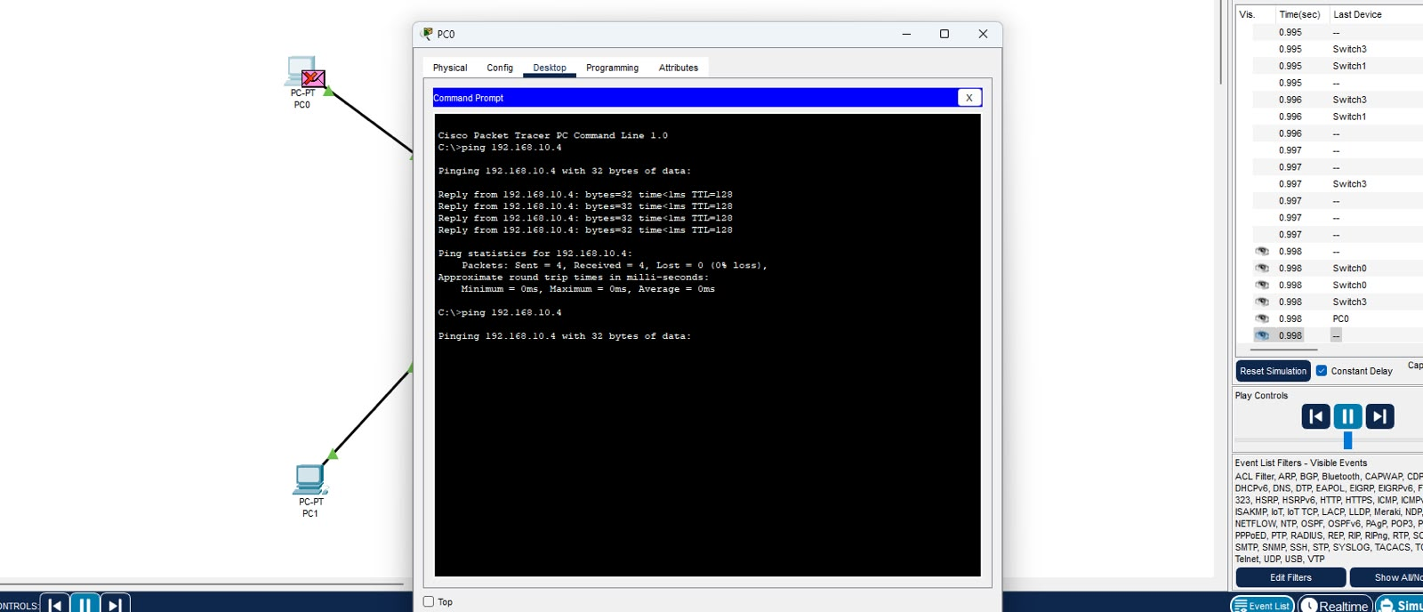
Fig. 8: Ping results among the PCs of the mesh topology

5.5 Hybrid Topology
As an additional exercise, several of the above topologies were merged into one larger hybrid network. Ping requests between PCs located in different sections confirmed that the entire network operated correctly as a whole.
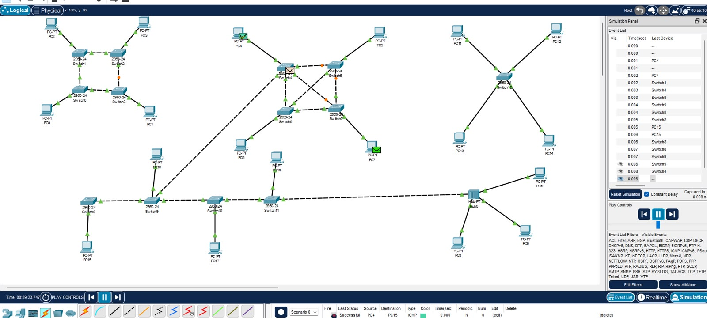
Fig. 9: Hybrid topology in Cisco Packet Tracer
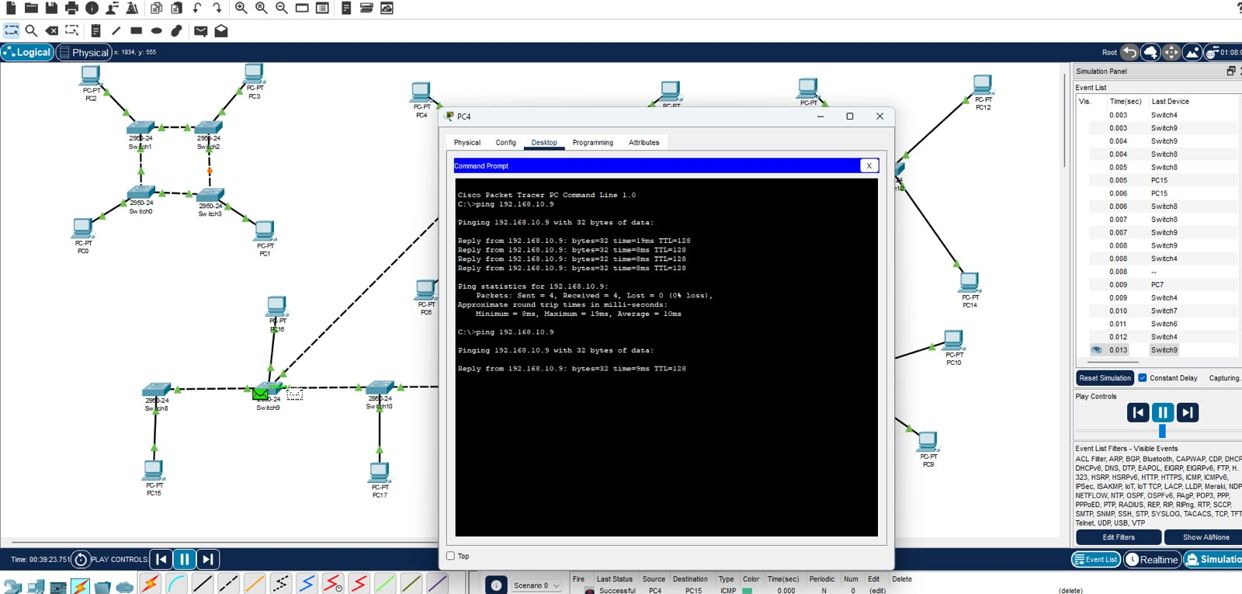
Fig. 10: Ping results among the PCs of the hybrid topology

6. Result
Bus, star, ring and mesh topologies were implemented in Cisco Packet Tracer with three computers each. Once IP addresses were configured, ping confirmed that the computers could communicate in every topology.

7. Conclusion
This lab gave me a clear picture of how different topologies are structured and built in Packet Tracer. The bus is simple and inexpensive but depends on a single backbone. The star is easy to manage since all devices connect to one switch. The ring joins devices in a loop, and the mesh offers direct links between all devices, making it the most reliable yet the costliest to cable. Ping tests confirmed that each network was set up correctly.

